**Forest Peoples Programme**

1. **Project title:**

**Promoting the rights of forest peoples in national and international policy-making on REDD and related forest and climate initiatives (2010-13)**

1. **Project summary:** This project works directly with forest communities and forest peoples’ organisations in Africa, Latin America and Asia to enhance the capacity of indigenous peoples and civil society to assert their rights and participate in international and national forest and climate negotiations, standard-setting and policy formulation. Key actions have been undertaken with local partners and communities to gather lessons from REDD+ planning and pilot projects in eight tropical forest countries (Peru, Guyana, Suriname, Panama, Paraguay, Cameroon, Democratic Republic of Congo and Indonesia). Results and insights have been shared with national and international policy makers via global and local dialogues, plus through publication and circulation of briefings, reports, community statements and press and media releases.

**3. Project information**

* **Period:** July 2010 – Dec 2013; Budget: 10.4 million kroner; expenditure to date: ≤ 9 million kroner.
* **Goal:** To promote the rights of indigenous peoples and forest-dependent communities in international, national and sub-national policies, programmes and pilot projects to curb forest loss and tackle climate change.
* **Target group:** 83 million forest dependent peoples in eight forest nations(Peru, Guyana, Suriname, Panama, Paraguay, Cameroon, Democratic Republic of Congo and Indonesia)
* **Local partners:** *Fundación para la Promoción del Conocimiento Indígena* (FPCI) in Panama; the Amerindian Peoples' Association (APA) in Guyana; *La Asociación Interétnica de Desarrollo de la Selva Peruana* (AIDESEP); *Federación por la Autodeterminación de los Pueblos Indígenas* (FAPI) in Paraguay; the Association of Village Captains (VIDS) and the Association of Saamaka Traditional Authorities (VSG) in Suriname; Okani and *Centre pour l’Environnement et le Développement* (CED) in Cameroon; *Centre d’Accompagnement des Autochtones Pygmées et Minoritaires Vulnérables* (CAMV) and *Cercle pour la defense de l'environnement* (CEDEN) in the Democratic Republic of Congo; and Scale Up and Pusaka in Indonesia
* **Activity profile:** Activities include community training and capacity building; supporting forest peoples’ direct participation in policy-making and standard-setting, including in the UN Climate Convention; human rights training; legal and technical support to forest communities; securing land and resour­­­­­ce rights; monitoring international financial institutions and development agencies, including the World Bank forest and climate funds; and development of baseline information on community land rights and deforestation drivers.
* **Co-funders**: The Climate and Land Use Alliance (CLUA), Ford Foundation (Indonesia), Christensen Fund, The Ecology Trust, Rights and Resources Initiative

1. **Justification: *Human rights, social justice and equity are essential for successful long-term action to curb deforestation and combat climate change***

With an estimated 1.5 billion people dependent on forests for their daily livelihoods, many of them among the world’s poorest, awareness has grown that inappropriate and imposed forest and climate schemes may harm local livelihoods and risk violating the rights of forest-dependent peoples.

In collaboration with forest peoples’ organisations and networks, and other NGOs, this rights-based project has played a pioneering role in highlighting the importance of rights and governance issues in international and national policy making for reducing greenhouse gas emissions from deforestation and land use change. The project has worked in alliances with forest peoples’ networks and the global movement of indigenous peoples to make important contributions to the setting of new global social standards for forest and climate finance and programmes. A major landmark was secured in late 2010 when the world’s governments agreed to apply rules (known as ‘safeguards’) under the UN Climate Convention to protect rights in national and international forest and climate policies and finance. Civil society projects like this one are essential to make sure that States and companies are actually putting social justice and rights principles into practice in national policies and local projects. Since the adoption of the Cancun Agreements, this project has continued to work with forest peoples to try and ensure that governments are living up to their commitments to respect local livelihoods.

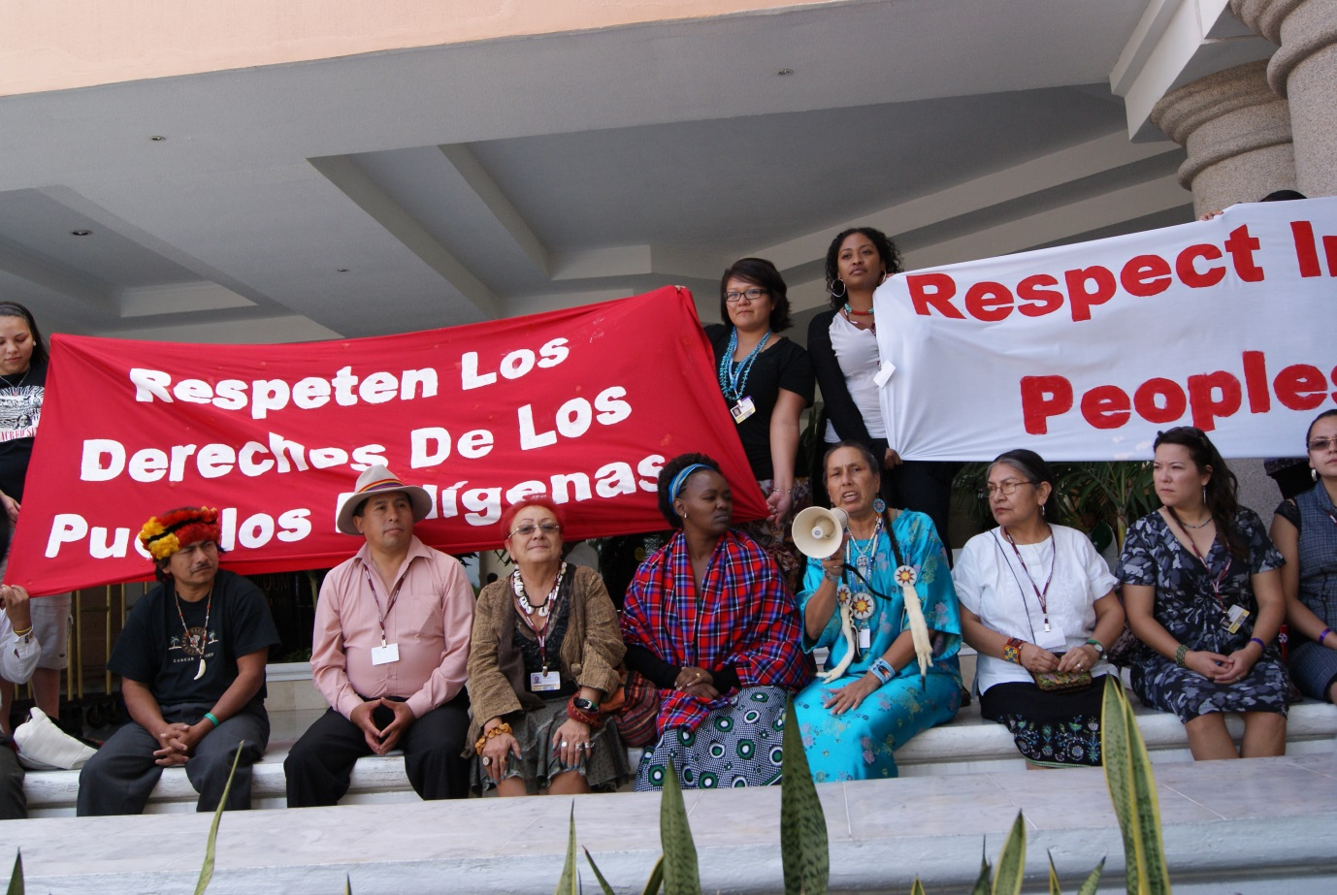

Indigenous peoples demand respect for their rights at UN Climate Convention in Cancun in December 2010 © Francesco Martone, Forest Peoples Programme

1. **Results**
2. **Binding safeguards established at the global level for forest and climate finance and initiatives**

Under this project, Forest Peoples Programme (FPP) has worked with the indigenous peoples’ caucus and like-minded NGO allies to make multiple submissions and statements to the UN Climate Convention calling for accountable finance and proper regulatory frameworks for forest and climate investments. The resulting UN Cancun Agreements break new ground within the framework of a multilateral environmental treaty because they make direct reference to the need for countries to uphold their human rights obligations as an integral part of public policies and actions to tackle climate change and land use emissions.

This step forward in global environmental policies has prompted governments and global climate policy makers to fully recognise the need to apply social and environmental safeguards to ensure sustainable outcomes in global forest and climate initiatives. The UK government, for example, has publicly affirmed that secure tenure rights are essential for sustainability in forest and climate policies and programmes. These gains are now being used by civil society to ensure that the UK’s International Climate Fund, and other global climate funds, are fully accountable to forest peoples and apply safeguards in line with the Cancun Agreements.

1. **REDD finance and technical cooperation agencies have adopted rights-based standards and guidelines**

As a result of focused advocacy targeting international agency social rules for forest and climate schemes, progressive standards have been adopted by various international organisations involved in forest and climate initiatives. New social commitments by donor agencies and the private sector have opened up unprecedented space for forest peoples to raise safeguards and accountability issues linked to climate policies and investments at the national and global levels.

One concrete example is the UNREDD Programme’s adoption of robust guidelines on free, prior and informed consent (FPIC) that are fully in line with international law. These guidelines are already being used by forest peoples in countries like Indonesia and Panama to press agencies to ensure good faith processes for prior consultation and FPIC.

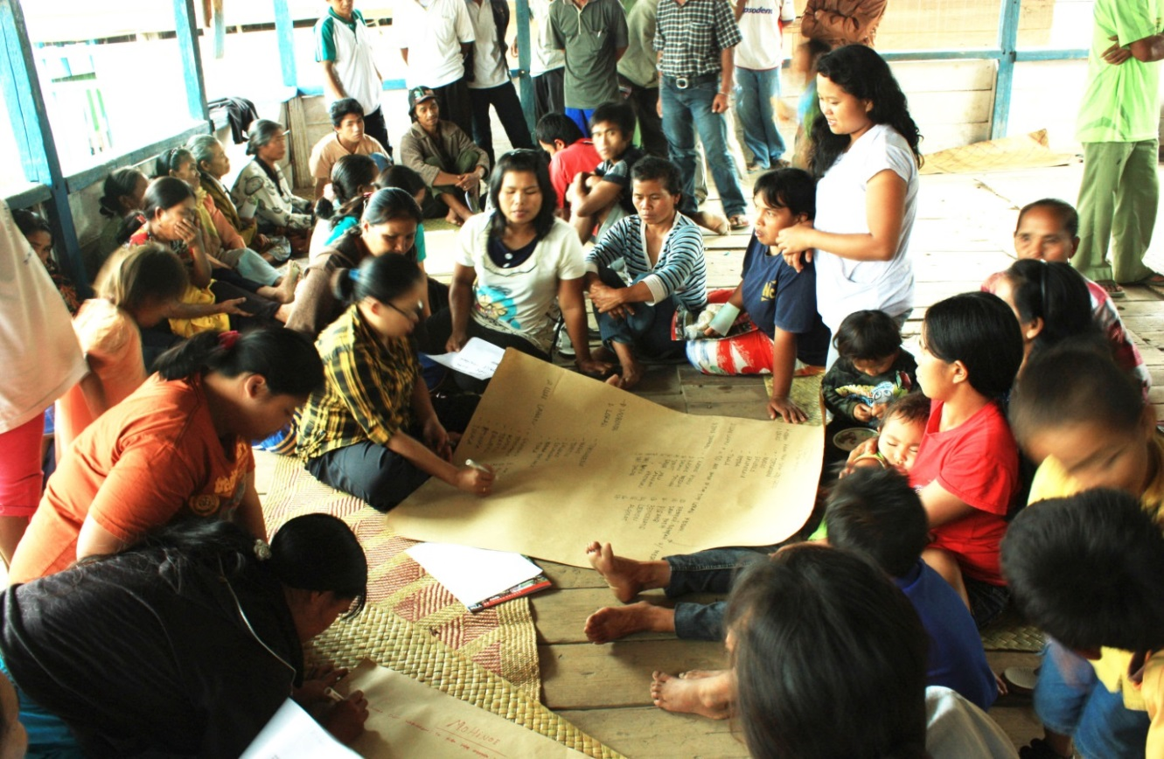

Community in Central Sulawesi, Indonesia, discusses UNREDD plans for pilot project affecting their lands and forest (October 2011) © Y L Franky

1. **Capacity and awareness raised among forest peoples about rights issues in forest and climate policies**

Community training activities and materials compiled for use by indigenous peoples and their allies under the project have increased community and civil society understanding of forest policy, rights and climate change issues, leading to effective engagement of forest peoples in national and sub-national REDD policy discussions.

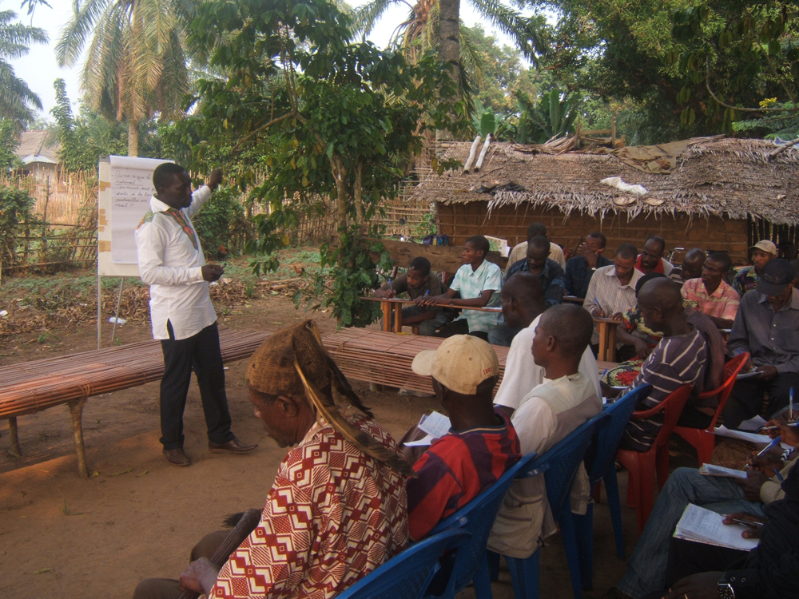

Community legal training on human rights and REDD in the Democratic Republic of Congo (June 2013) © CEDEN

1. **Implementation gap exposed through joint work with local partners and affected forest communities**

FPP tracking of pilot forest and climate projects and programmes, and monitoring of safeguard compliance, has resulted in multiple publications highlighting implementation problems, which in turn have increased awareness among REDD policy makers of actions required to apply social standards in climate policies and investments. Examples include FPP and partner reports uncovering compliance failures in the Peruvian Amazon, Guyana, Cameroon and Indonesia.

[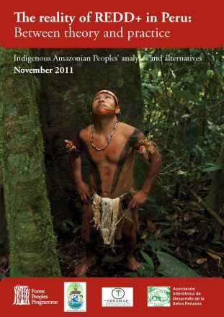](http://www.forestpeoples.org/topics/redd-and-related-initiatives/publication/2011/reality-redd-peru-between-theory-and-practice-i)[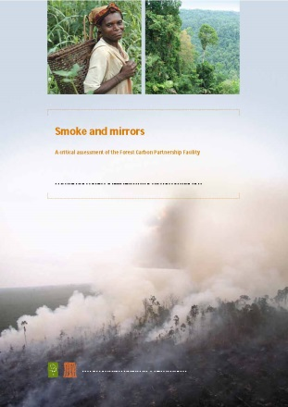](http://www.forestpeoples.org/topics/redd-and-related-initiatives/publication/2011/smoke-and-mirrors-critical-assessment-forest-ca)[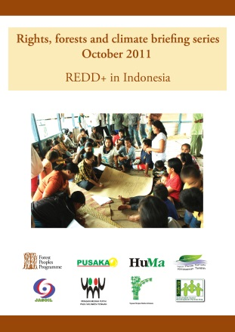](http://www.forestpeoples.org/topics/redd-and-related-initiatives/publication/2011/fpp-series-rights-forests-and-climate-october-2)

1. **Learning experiences**

For over three years this initiative has been creating learning arenas and sharing generated knowledge among a wide range of involved groups. This has been achieved through high level dialogues with government and policy makers and via FPP’s E-Newsletter which reaches 7000 readers worldwide in 4 languages. From 2010 to 2013 we published 32 articles related to climate finance and forests, and a special edition E-Newsletter on safeguard policies (<http://www.forestpeoples.org/topics/forest-carbon-partnership-facility-fcpf/news/2013/04/safeguards-redd-financing-schemes>).

The project has further advanced its learning approach by carrying out practical work on the ground with forest peoples in 2012-13, including through the development of highly innovative participatory land tenure assessment approaches for low carbon development with the Amerindian Peoples Association (APA) in Guyana and with local partners in Peru. This ground-breaking grassroots work on sustainable climate investments includes local assessments of deforestation drivers. Initial results are likely to be shared with policy makers by late 2013/early 2014.

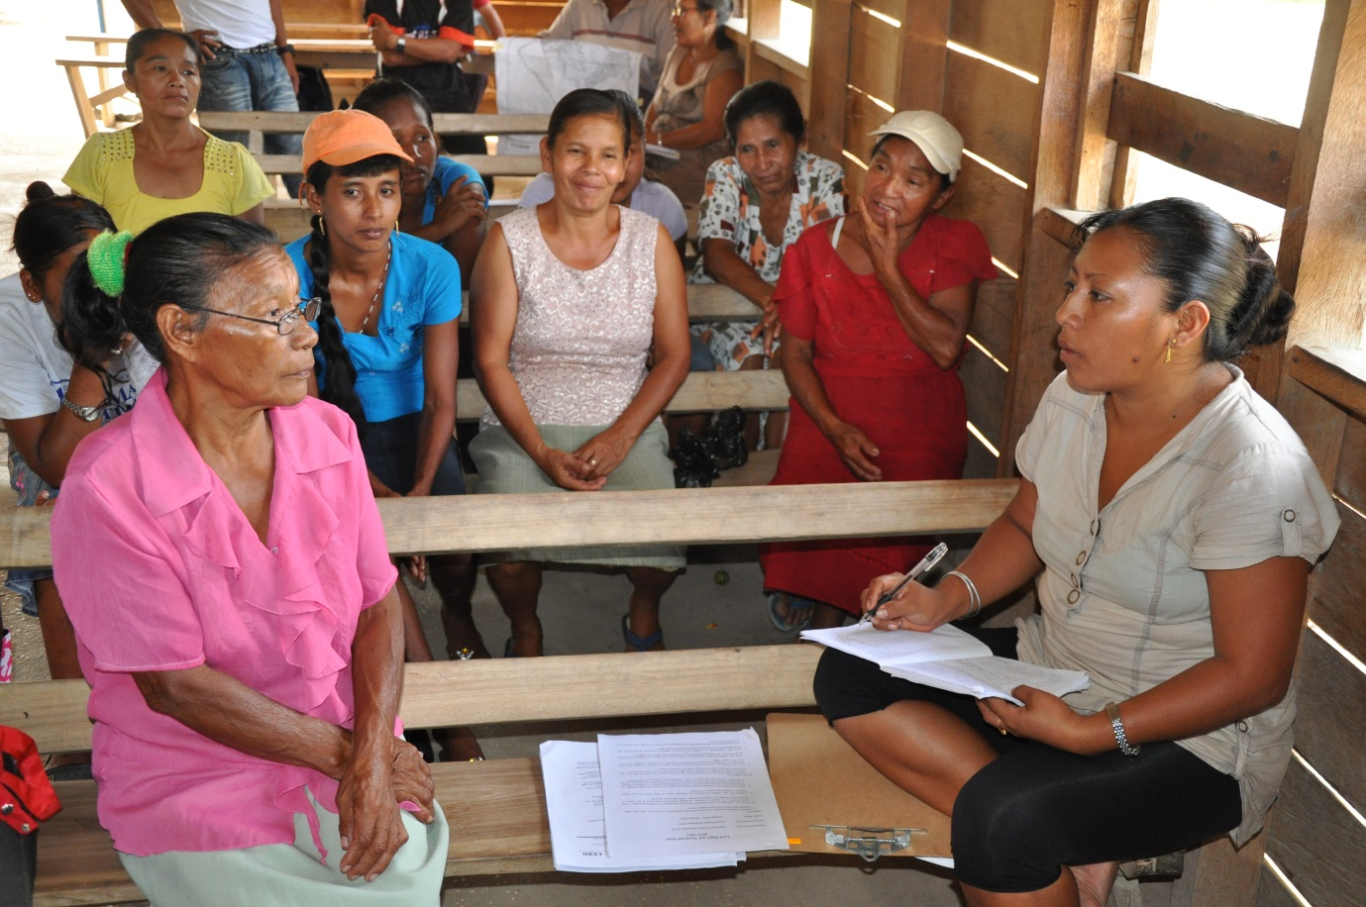

Amerindian team discusses women’s rights and land tenure issues in REDD+ and low carbon development policies (February 2012) © Tom Griffiths, Forest Peoples Programme