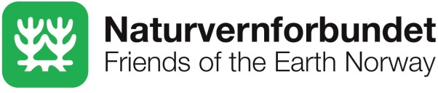
Results sheet:
Friends of the Earth Norway and Rainforest Foundation Norway

1) Project title
REDD and international climate talks: A binding framework for emissions reductions, forest peoples’ rights and preservation of biological diversity.

2) Project summary

Through advocacy and providing valuable input to decision makers, the project aimed to ensure the rights of indigenous peoples and local communities, the preservation of biodiversity and effective emissions reductions in the process for creating a REDD+ mechanism under the UNFCCC.

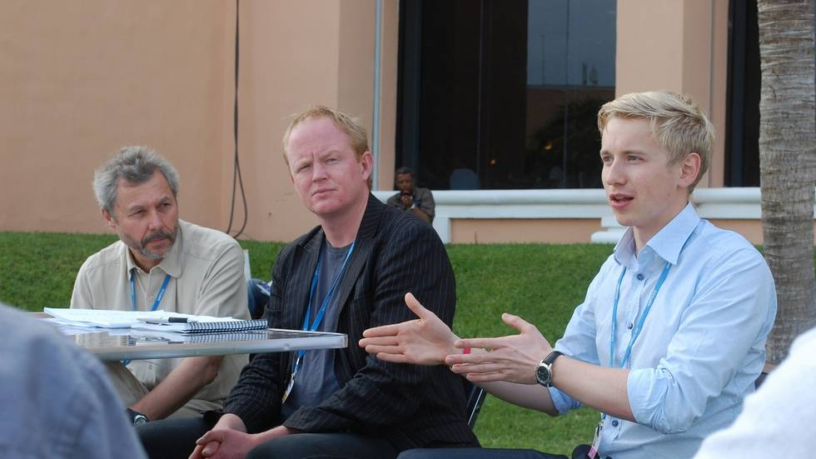
Friends of the Earth Norway and Rainforest Foundation Norway hold a press conference for Norwegian media on the margins of COP 16 in Cancun in 2010. From the left: Lars Løvold, Lars Haltbrekken and Bård Lahn. (Photo: Turid Furdal, Stavanger Aftenblad)

3) Project information

The support period ran from 2010 to 2013, with a budget frame of 3.5 million NOK in total. The goal of the project was described as follows:

«Central decision makers in the negotiations on a new climate agreement under the UNFCCC have been influenced to secure the rights of indigenous peoples and local communities, preservation of biological diversity and effective emission reductions in the design of a REDD+ mechanism under the UNFCCC.»

The target group was primarily the national parties in the UNFCCC climate talks. Important secondary target groups were international civil society, as well as civil society, media and decision makers in Norway.

The activity profile included continuous presence in and tracking of the UNFCCC negotiations, including meetings, round tables, side events, etc. In addition, activities included the production of reports, briefings and other written materials to provide concrete and constructive input to the negotiators.

4) Justification of project

A rights-based approach

We believe that to achieve permanent emission reductions and positive results for forest-dependent peoples and biodiversity, a REDD mechanism must build on a rights-based approach, with a high degree of participation from forest peoples. Experience shows that top-down approaches to forest protection are mostly unsuccessful, and can even do significant harm.

Climate research suggests that tropical forests will not survive dramatic climate change. The ambition for emission reductions in an overall climate framework will have significant influence on whether forest protection through REDD will be permanent or not.

Together, Naturvernforbundet and the Rainforest Foundation Norway, with our expertise on international climate negotiations and extensive network of partners working “on the ground”, are uniquely positioned to influence the REDD negotiations in a constructive manner.

5) Results

Decision makers in the negotiations have been made aware of the need for a REDD mechanism that includes rules to ensure that national REDD plans build on the rights and participation of indigenous peoples and local communities. We contributed to concrete proposals from civil society on how this could be achieved, that have been presented through multiple channels to the parties.

Parties in the negotiations have also been made aware of the need for a REDD mechanism that prioritizes the protection of intact natural forests, through rules that prevent incentives for industrial logging and conversion of natural forests into plantations. We contributed to concrete proposals on how this could be achieved, that have been presented through multiple channels to the parties. The safeguards decided in the Cancun Agreements from 2010 stand as the most concrete result of this work.

Together with civil society in the North and South we have worked effectively to influence the shaping of the rules of a REDD mechanism, through consensus-building around concrete proposals and work towards the parties.

In Norway, we have contributed to continued debate about the international climate talks and the role of forests as part of this, through seminars, media packages, among other things.

As mentioned, the Cancun Agreements and its REDD+ safeguards is perhaps the most concrete result of our work. This result was achieved through a range of efforts, including building alliances in civil society and with key countries and providing qualified input at appropriate junctions, often based on “on the ground” lessons made by the Rainforest Foundation. The opportunity to work closely with Norwegian authorities was important, considering the key role that Norway has played in REDD+ negotiations.

Establishing precise causal relationships between concrete outputs and outcomes such as those of Cancun is difficult in a complex policy arena like the UNFCCC.

6) Learning experiences

One of the most important political lessons we have learned through our work relates to what has become known as non-carbon benefits. Though not strong enough in our opinion, the Cancun safeguards represented a significant step forward towards an effective REDD mechanism. However, making these safeguards stronger remains difficult since they are among many forest countries regarded as undue conditionalities on the side of donor countries.

This stalemate has contributed to the increased significance of the debate on the need to provide positive incentives to the so-called non-carbon benefits, or co-benefits of REDD. Many would argue that these co-benefits are in truth the core activities that provide an enabling environment for REDD to succeed.

This enabling environment can not in our opinion be fully attained through safeguards alone, however strong these may be. The safeguards are in their very nature based on a principle of “do no harm”, and this does not provide the sort of positive incentive we believe to be needed.

Another important learning experience relates to support and legitimacy with civil society. For us it is clear that progress towards an effective REDD+ mechanism requires support and input from civil society, including environmental non-government organizations. At the same time, the willingness of civil society to engage in such a process often requires a minimum of legitimacy and sense that things are moving in a good direction.

In the last part of our project from 2010 to 2013, we saw this support erode in one of our networks, Friends of the Earth International. The lack of progress in the negotiations, together with several worrisome developments in the implementation of REDD+ on the ground in many countries, served as motivation for this network to move from a position of hesitation to one of rejection of REDD+. If such a trend continues and grows, it could in turn make future progress on REDD+ even more difficult, creating a vicious circle.

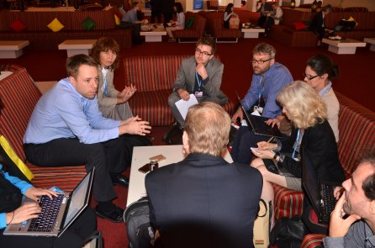
Members of the REDD+ Safeguards Information System Working Group meet with the Norwegian REDD+ negotiator at COP 18 in Doha in 2012.

