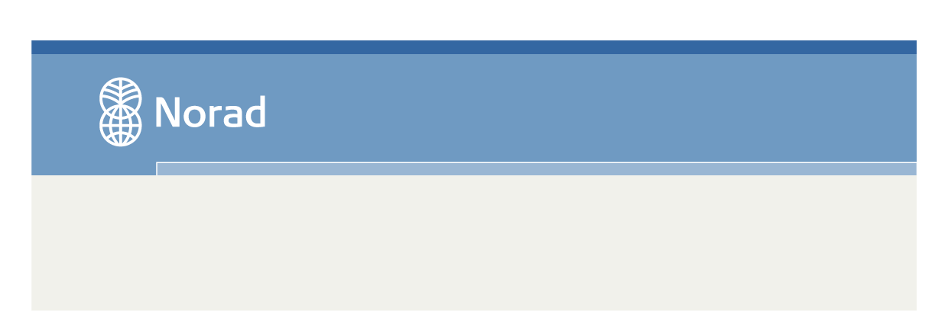

For year: 2018

Civil Society Department

Her begynner teksten…

FORM FOR **UPDATED IMPLEMENTATION PLAN AND BUDGET**

for grant recipients with ongoing agreements

*(Deadline for submission: November 1*)

The form for updated implementation plan and budget is used to document changes to plans and budgets for the coming period compared to the plan on which the agreement with Norad is based.

The form should be completed with reference to the agreement and approved plans. Grant recipients may use their own formats as long as all items in the form are included. In the form, ‘the Project’ refers to the entire intervention encompassed by the agreement with Norad, be it a project, programme or a portfolio of projects/programmes.

**1. General**

1.1 Name of the grant recipient:

1.2 Norad’s agreement number:

1.3 Norad’s agreement name:

1.4 Agreement period (from year through year):

1.5 Annual plan for the year: 20XX

**2. Significant changes to plans, budgets and organization**

Significant changes to the Project primarily encompass changes that require approval by Norad according to the grant recipient’s prevailing agreement. It is therefore advisable to check the wording of the agreement.

Give a brief account of the changes. The nature of the changes must be clearly described, along with their consequences for the Project and the reasons for the changes.

**3. New projects/programmes, if appropriate**

Normally, there is *no* allowance for the establishment of new projects/programmes during an agreement period. However, extraordinary situations may arise in which a project/programme must be phased out or changed to such an extent that the changes may appear to constitute a new project/programme. Examples of such situations may be new political frameworks or wars and conflicts in the recipient country.

The wording of the grant recipient’s prevailing agreement will show how the organization should proceed in such cases, for example whether a written invitation from Norad will be required.

**4. Budget – financial need – grants from the Norwegian MFA/Norwegian embassies**

4.1 Project budget and financial need for the coming year

|  |  |  |  |  |  |  |  |
| --- | --- | --- | --- | --- | --- | --- | --- |
| **20XX**  **Country/ region/**  **thematic area *)**  *(Amounts in NOK 1000)* | **Total budgeted**  **Project costs** | **Total budgetedProject income** | **Income from other sources**  **\*\*)** | **Org.’s own contri-bution** | **Remaining financial need = Total Norad grant required, incl. overhead/ indirect costs covered by the grant** | **Norad grant incl. overhead/ indirect costs covered by the grant - as laid out in the budget annex of the agrmt.** | **Change in financial need for Norad grant** |
| **Country** |  |  |  |  |  |  |  |
| **Africa** |  |  |  |  |  |  |  |
|  |  |  |  |  |  |  |  |
| **Asia** |  |  |  |  |  |  |  |
|  |  |  |  |  |  |  |  |
| **Latin America** |  |  |  |  |  |  |  |
|  |  |  |  |  |  |  |  |
| **Global initiatives** |  |  |  |  |  |  |  |
| **Theme** |  |  |  |  |  |  |  |
| **TOTAL** |  |  |  |  |  |  |  |

**\***) Organisations with smaller agreements *without* so-called sub-units fill in per project per country, using short project names.

Organisations with larger agreements *with* sub-units fill in their total planned effort per country and regional programme/thematic area.

**\*\*)** All income beyond organisation’s own contribution and Norad grant.

4.2 Provide a brief account of all grants provided by or applied for from *the Norwegian MFA and Norwegian embassies*, whether these are part of the Project’s funding or not.

**Attachments to the form**:

1. Organisations shall submit a revised detailed budget for the actual year.
2. In September each year, organisations that have an agreement *with* sub-units will receive an Excel spreadsheet from Norad to be completed with detailed information on their budget per sub-unit for the coming year (statistical overview).

**5. Results monitoring and evaluation**

Provide an overview of planned evaluations and reviews for the coming year:

For agreements that include sub-units, state the number of each sub-unit if possible.

Describe how the evaluations will be financed and their anticipated budget per year.

Date:

________________________

Name and signature

Title