Sustainable agriculture and forest conservation: How can sustainable agroforestry systems and farming contribute to national REDD+ strategies in Central America

Project title: “Sustainable community based agroforestry and reduced emission systems in Central America – PASCA REDD Comunitaria”

Implementing organization: The Development Fund (Utviklingsfondet)
Project summary
The main objective of the project was to establish and validate sustainable agroforestry systems that reduce the pressure on forest from agricultural activities. In addition, the project established and tested local management and monitoring plans for micro-watershed, aiming at piloting community models for REDD+ and preparing local communities for REDD+ in Central America.

Project information:
- Support period and budget frame, expenditures to date:
  - Support period: 1 June 2010 – 31 December 2012
  - Budget frame: NOK 4.5 million for the whole period.
- The goal of the project:
  - To reduce green house gases in the atmosphere through increased agro-forestry and reducing deforestation
- Target group:
  - Low income, vulnerable rural families in 4 communities in Guatemala, Honduras, Nicaragua and Costa Rica
  - Students in basic education and the education system
  - Local and national authorities
- Geographical location: Guatemala, Honduras, Nicaragua and Costa Rica
- Local partners and their responsibilities in the project.
  - Asociación de organizaciones de los Cuchumatanes (ASOCUCH) in Guatemala
  - Proyecto Aldea Global in Honduras
  - Fundación para la Autonomía y el Desarrollo de la Costa Atlántica de Nicaragua (FADCANIC) in Nicaragua
  - Instituto de Investigación y Servicios Forestales at the National University of Costa Rica (UNA-INISEFOR) in Costa Rica
- Activity profile:
  - Agriculture and sustainable landscape
  - Policy and advocacy

Background and context:

Uncertain climatic conditions, degraded ecosystems and soils, and lack of appropriate technology and knowledge place severe constraints in small-scale farmers’ capacity to ensure a production that full basic needs and sustainable management of natural resources. Central America has high rates of deforestation. Between 1990 and 2005, almost 20% of the region’s forest reserves disappeared. Expansion of agriculture or pasture structural adjustment and trade liberalization, perverse fiscal policies with low fees for timber concessions and subsidies to agriculture and cattle activities are some drivers of deforestation. Although small-scale farmers are not the main drivers of deforestation, scarce land resources and unsustainable practices put forest reserves under pressure and underpin deforestation and ecosystem degradation. Reduced soil fertility, degraded land and depleting groundwater reserves reinforce the pressure on forests as farmers seek new areas to cultivate to fulfill their basic needs.

Modification of agricultural practices can reduce pressure on forest and contribute to reduction of emissions. More efficient and sustainable agricultural practices are also crucial for poverty reduction and environmental sustainability. Many small-scale farmers are forest dependent, and their role in forest conservation has been underestimated. The rural poor is a sector that commonly has been excluded from policy making and development processes. This, in turn, reduces the sustainability and success of such processes. Small-scale farmers and community leaders, in many cases indigenous people, can play a crucial role in making REDD+ work, but this requires the development of community based REDD+ models that can be adopted in national REDD+ strategies.

As a result of a commonly expressed in reducing deforestation, the Central American countries have been moving forward with REDD+. However, when this project started, REDD+ processes were incipient in the region, with all countries integrated in this project but Costa Rica, mainly focusing on drafting and finalizing their R-PP. The lack of an international framework that guarantees social and environmental benefits as well as the rights of forest dependent people and indigenous people, put several constrains for the success of any REDD+ strategy. The project was one of the first regional initiatives on REDD+, and the only known initiative combing practical experiences with sustainable agriculture to reduce pressure on forest with a direct REDD+ approach in the region.

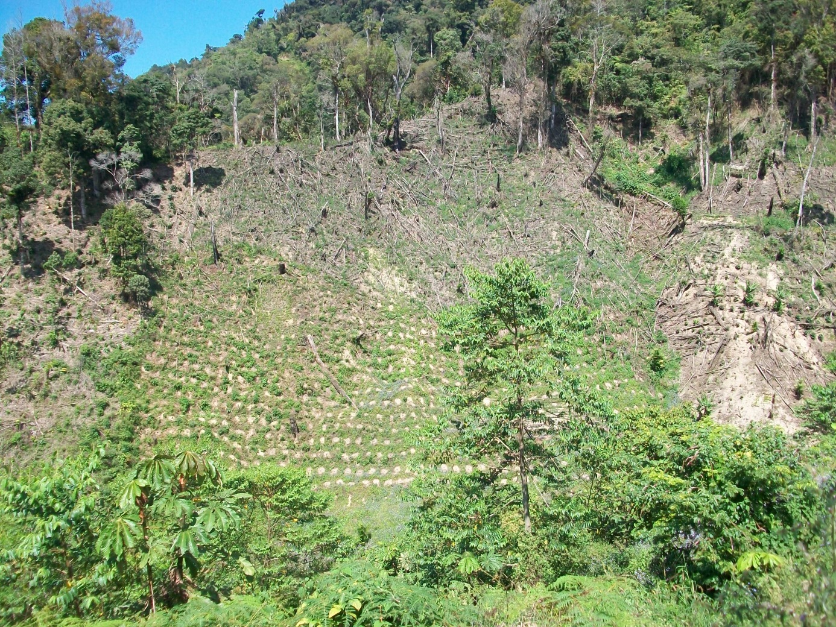

Picture: Deforestation from agriculture in Honduras

Main results and impact

- Models for sustainable agriculture that reduce the pressure on forest have been established: 326 farmers have established agroforestry systems and adopted sustainable agriculture techniques. The model includes integral farm planning, adaptation of soil conservation methods, reforestation and crop diversification. By increasing the output from the plots, farmers can maintain their forest reserves on the farms. Agroforestry systems in forest border areas contribute to reduce forest and ecosystem degradation. De to the short period since the systems were established, it has not been possible to assess the long-term impact of the systems, however the positive effect of agroforestry systems is likely to contribute to reduced pressure on forests. Other positive effects are increased outputs from farms and crops, which will have a positive impact on poverty reduction and improving small-scale farming families’ livelihood.
- Energy-saving cooking stoves have reduced the consumption of firewood by 45%: 773 households have installed and are using energy-saving cooking stoves. This has led to a significant drop of the consumption of firewood.
- Local forest management plans at micro-watershed level established and implemented: Farmers have participated in the development of local forest management and monitoring systems. The management plans have contributed to reducing slash and burn practices, and reducing the frequency on forest fires.
- Local communities are better prepared for REDD+: 635 farmers, indigenous people and community leaders have been trained in REDD+ and forestry. Some of them are represented in national REDD+ working groups and influence actively national REDD+ processes. By increasing their knowledge and having established systems for forest management and monitoring, the communities have now established a common understanding of the challenges and benefits from REDD+. Practical community experiences can make REDD+ more relevant for local communities.
- Guidelines for environmental education in schools developed and in use

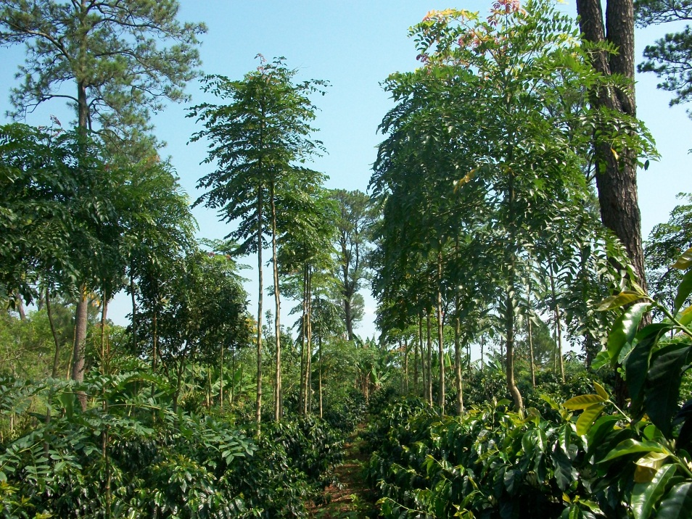

Picture: Coffee and agroforestry systems

Contribution to national REDD+ processes:

With its efforts to combine practical experiences in the field with policy work, this project has pioneer in REDD+ in Central America. REDD+ processes were incipient in the region at the time this project started, and there had been no previous effort to combine practical implementation of forest conservation and sustainable agriculture with a REDD+ and policy approach at regional level. The knowledge on REDD+ among farming communities was practically absent, and very few NGOs and farmers organisations were involved in piloting community REDD+ models.

Farmers, indigenous people, local communities and local authorities have been involved in REDD+ processes. Farming has been linked to forest management and conservation, and local communities have been prepared to plan, implement and monitor REDD+ projects. This is important as several countries have finished or are finishing their R-PP and become eligible for funding from the FCPF scheme. By the time the project ended, there were few other pilot projects on REDD+. CCAD-GIZ has one program on REDD+

At local level, the main contribution to REDD+ has been:
- Communities (including farmers, women, and indigenous people) have knowledge on REDD+ and experiences from designing and implementing local management plans. This has prepared them to plan, implement and monitor REDD+ projects
- Local committees on management of natural resources are established, integrating farmers, community leaders and governmental authorities (5 in Honduras, 2 in Guatemala, 1 in Nicaragua)
- Forest friendly agriculture system: Agroforestry systems reduce the pressure on forests.
At national level, the project has contributed to:
- Farmers and partners participate in REDD+ working groups, national CSO networks, platforms on climate change. Particularly in the case of Guatemala, farmers and indigenous leaders contribution to the country’s R-PP has been important, and beneficiaries from the project have worked in alliance with other indigenous movements and civil society network. Before the project started, none of the partners nor farmers were represented in REDD+ working groups
- Practical experiences from the field are used in the discussions and preparation of REDD+ strategies
- ASOCUCH has become an implementing partner of Guatemala’s R-PP. This is a direct result of the project, and gives the organisation a possibility to access funds and influence the implementation and monitoring of the R-PP.
At regional and international level, the main contribution has been:
- Alliances between indigenous and afro-descendent populations in Honduras and Nicaragua with CSO, universities and autonomous governments (Nicaragua)
- 2 partner representatives were part of national delegations during the conference of the parties COP 16 and COP 17.
- Better knowledge and understanding of regional policy discussions and cooperation among CSO and farmers

Learning experiences:

- Policy and advocacy is strengthened when combined with practical project experiences from the ground: The project partners had little experience in policy and advocacy at this level before and REDD+ was a new topic for the partners. The combination of project implementation on the ground and policy work was a very positive experience. This made the policy processes more relevant and concrete for farmers and community stakeholders, and increased their interest in participating in theses processes. It also added a new value to the policy work and filled a gap in the national processes.
- The watershed perspective visualizes synergy between mitigation and adaptation: The focus on watershed for the management of forests proved to be very useful. For farmers, mitigation become more relevant when they see the relevance and correlation with adaptation, and the watershed perspective contributed to visualize this correlation. This made it easier to involve farmers in the preparation and implementation of management plans.
- Baseline and documentation of results require adequate systems and software: To establish and document results and impact on forest degradation and deforestation, any initiative should have adequate systems and software for establishing and updating baselines. This is resource demanding and often beyond the financial capacity of small projects. In this particular case, the budget was distributed among four countries and partners, and was insufficient to cover the costs for new software and programs.

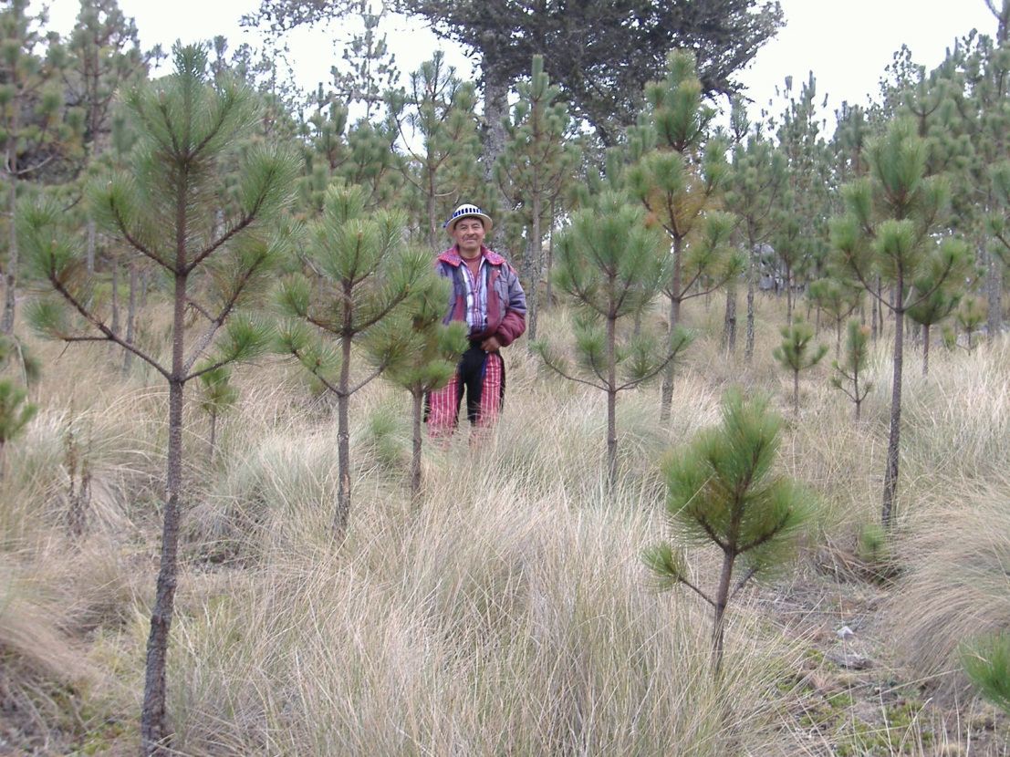

Picture: Indigenous farmers play an active role in forest conservation and management in Sierra de los Cuchumatanes in Guatemala

