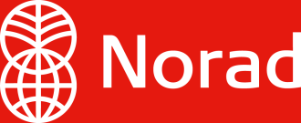

Declaration concerning ethical guidelines

According to Norad’s guidelines, grant applicants shall confirm that the company/organisation/institution has ethical guidelines. As a minimum, the guidelines shall include the provisions and requirements listed in “Ethical guidelines - Guide for Norad’s grant recipients”, March 2014.

This declaration is valid for
Company/organisation/institution |  | Organisation number
Address |  | Postal code
Place

I am familiar with Norad’s ethical guidelines, and hereby confirm that …………………. (name of company/organisation/institution):

- has ethical guidelines that as a minimum, contain the provisions and requirements listed in “Ethical guidelines - Guide for Norad’s grant recipients”
- will strive to ensure compliance with these guidelines in the entire organization at any time
- will grant Norad access to the guidelines as well as information about the work undertaken to ensure compliance with these, upon request.

Date General Manager

